Physical Education
Physical activity is an important part of a child’s life. Positive experiences create positive changes in a person’s self-image which can enhance his or her physical, mental and social growth. GLS Physical Education Program is designed to provide a variety of activities, challenges and experiences to promote physical fitness, increase knowledge and create an atmosphere for positive social interaction.
K-4 Curriculum
Skill Themes and Fitness Concepts
Students will experience a developmentally designed program of skills and fitness development, including skill based practice, games, and dances. The following motor skills and fitness concepts are included in these activities;
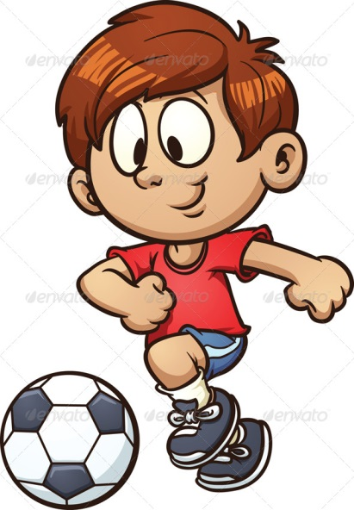
- Body Awareness
- Balancing
- Chasing, fleeing, and dodging
- Striking with implements
(Short and long handled)
- Rolling
- Throwing and Catching
- Traveling
- Volleying
- Dribbling
- Transferring weight
- Jumping and Landing
- Cardiorespiratory endurance
- Flexibility
- Muscular Strength and Endurance
- Fitness Testing
Participation is the foundation of the program. Since children are competitive by nature our emphasis is to keep winning in perspective, encourage fair play and good sportsmanship, recognition to those who give their best effort, develop an environment where children can feel free to participate and enjoy themselves regardless of skill levels.

Grass Lake Grade School

